|  |  |  |
| --- | --- | --- |
| http://upload.wikimedia.org/wikipedia/en/3/3b/Asia_Pacific_College_Logo.png | **SM Foundation Incorporated Scholarship System Module 2: Existing Scholars** | http://1.bp.blogspot.com/-QtA0qwQbmY8/Tb5vY2CEf7I/AAAAAAAAFEw/es7fI6E4PMc/s1600/New+SMFI+Logo+-+Hi+Res_small.jpg |

|  |  |
| --- | --- |
| Team Member | Role |
| Caram, Fermin IV | Project Manager |
| Arroyo, Jason | Project Manager |
| Oncinian, Jose Louise | Database Administrator |
| Villacorta, Kevin | Database Administrator |
| Baclaya, Joreen | Software Engineer |
| Daswani, Syam | Software Engineer |
| Frias, Levi | Infrastructure Engineer |

|  |  |  |
| --- | --- | --- |
| **I. Environmental Scan** | | |
| **Volume of the Population:**  The total number of collegiate students in the Philippines is 3,563,396 and the total number of Higher Education Institutions is 2,374 as of Academic Year 2013-2014 (Commission on Higher Education, 2015).  SM Foundation Incorporated supports 1500 collegiate scholars (0.04% of the population) across 84 schools (3.54% of the total number) nationwide. | | |
| **Political Analysis**  SM Foundation, Inc. is a corporate social responsibility arm of the SM Group of Companies to help and reach the marginalized in the communities it serves by means of supporting their needs in Education through college and technical-vocational scholarship programs and donation of public school buildings. There is no intervention of the government with regards to how the SM Foundation do their tasks and nature of business because it is a non-government organization. Also, there is no conflicting law, trade policy, and trade restrictions as the foundation is a granting institution for the less fortunate to achieve good quality education. | **Economic Analysis**  Education plays a vital role with the economic growth of any country as the amount of goods and services produced by the population over a period of time will depend upon its citizens and if the quality of the outcome are poor, the sole reason are the ones who produced and their educational attainment is a big factor. Hence, SM Foundation Inc. helping the less fortunate and allowing more Filipinos to obtain an education are big steps towards helping maintain the economic growth the Philippines has been experiencing for the last 32 years. | **Social Analysis**  With the fast changing technology and big innovations, education has become a luxury that not everyone could have – some just simply adapted to this and just opt to find work instead of pursuing a degree while others persevered to finish their studies. The Filipinos tend to treat education as a treasure that cannot be stolen. Since SM Foundation Inc. helps more Filipinos acquire quality educations, the treasure that is education now becomes more available and possible to the Filipinos in the urban and even remote areas. |
| **Technological Analysis**  Handling a lot of records in papers is very troublesome for end users as the time cannot be efficiently used with regards to finding, validating, and updating the documents. SM Foundation Inc. uses Excel which is a proprietary software developed by Microsoft that could gather and accumulate the data they require from scholars to be accepted, sponsored, and assisted. It has features for data analysis, sorting, and managing the data the foundation collects. Although this is a good step, with the possible increase of the number of scholars and the data to be collected, Excel in the future would not be advisable. | **Legal Analysis**  Unfortunately, the scholarship granted by the foundation is only limited to household with income not more than Php 150,000 but once the high school graduate gets qualified, there is equal opportunity for all to acquire a good quality of education in the school and course of their choice. There are no health and safety issues with the foundation as that’s left to the students with how they manage their time in studies. The reason why SM Foundation limits their grant is because it is a not government run so no funding from the state and their focus is to give hope to the marginalized society and aid them attain their educational goals. | **Environmental Analysis**  According to the World Centric, paper manufacturing requires huge quantities of water and number of trees which causes deforestation, loss of habitats, and more others. Since the SM Foundation incorporated most of their processes in Excel, they save the use of paper and energy through its production. The stipends, allowances, and benefits are already given via cash cards that helps fight global warming because of avoiding the use of engines and vehicles for delivery. The less of use of materials that can negatively affect the environment is evidently seen in the current processes of SM Foundation. |
| **Recommendation:**  SM Foundation Incorporated performs an important service to Philippine society as a whole, however its limited technology is stunting its growth. SM Foundation Inc. should implement a scalable system that would allow easier access to their records while also providing less redundant and error-prone manipulation and analysis. | | |

|  |  |
| --- | --- |
| **II. Introduction** | |
| **Background of the Client:**  SM Foundation Incorporated was founded in 1983 by Henry Sy, Sr. and Felicidad T. Sy. As the corporate social responsibility arm of the SM Group of Companies, the Foundation employs corporate assets to help improve the quality of life of less fortunate Filipinos nationwide. Its projects aim to evoke a positive change in both urban and rural communities through scholarships, medical missions, livelihood trainings, and housing projects. The Foundation is dedicated to building an environmentally-aware nation where every Filipino has the opportunity for self-improvement. | **Stakeholders:**   * SM Foundation * SM Scholars |
| **Problem Statement:**  SM Foundation Incorporated is currently processing all of their records manually through the use of Microsoft Excel spreadsheets. This method is error-prone, time-consuming, inefficient, and leads to many data redundancies; lowering the quality of service provided by SM Foundation. | |

|  |
| --- |
| **III. Analysis** |
| **Business Process Diagram** |

|  |  |
| --- | --- |
| **IV. Recommendation** | |
| **Project Description**  The project involves the development of a web-based system for SM Foundation Incorporated capable of consolidating the Foundation’s various scholar-related records and automating several of its business processes. | **Conceptual Framework:** |
| **System Configuration Diagram** | |

|  |  |
| --- | --- |
| **V. Diagrams** | |
| **Context Level Diagram** | |
| **Data Flow Diagram (Level 1)** | |
| **Entity Relationship Diagram** | |
| **Screenshots** | |
| **Scholar Login Screen** | **Admin Login Screen** |
| **Scholar Home Screen** | **Admin Home Screen** |

|  |
| --- |
| **VI. Conclusion** |
| SM Foundation Incorporated’s operations can greatly benefit from the implementation of the web-based system. The system allows the Foundation to perform every task it is currently performing through Excel, and further improves upon efficiency by automating calculations, reports, and notifications. |

# Appendix

## Data Dictionary

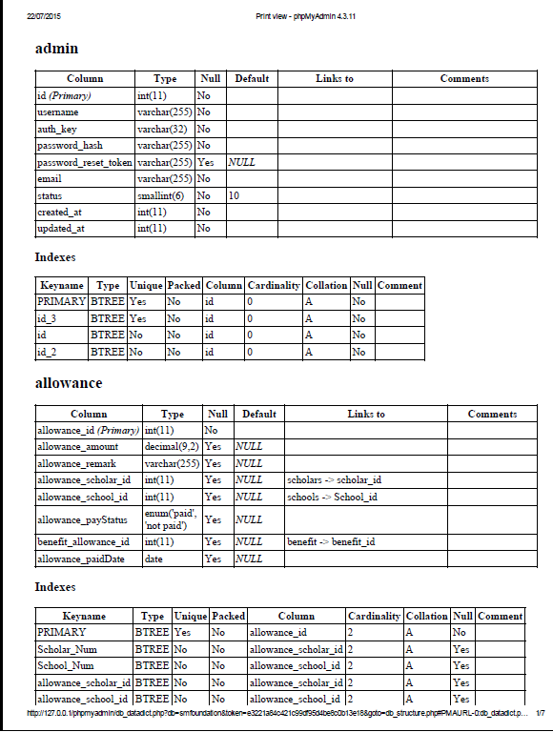

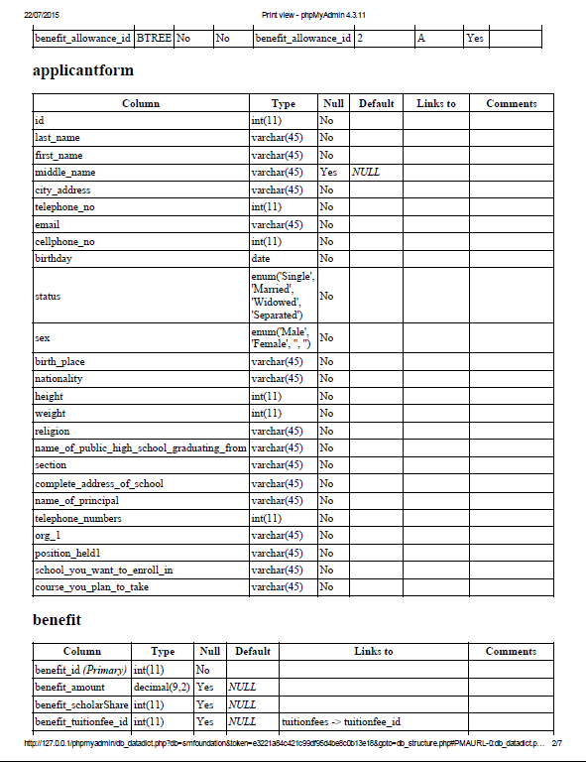

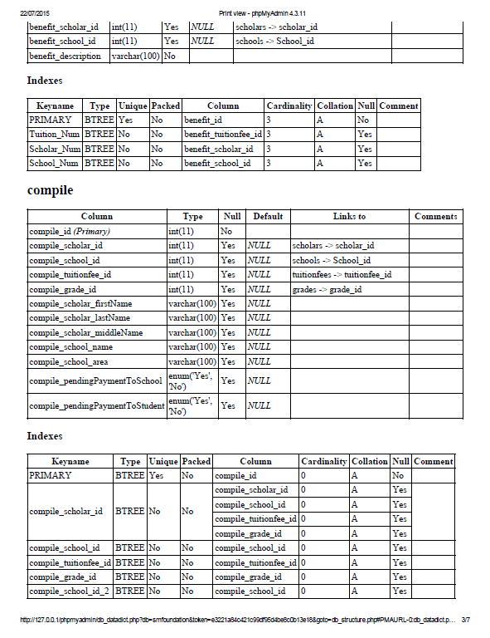

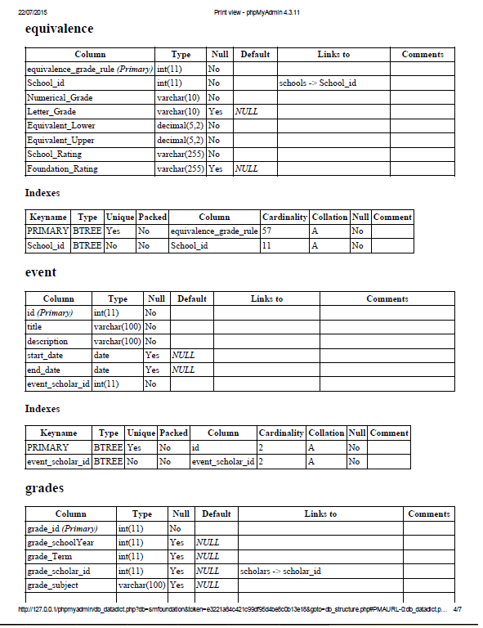

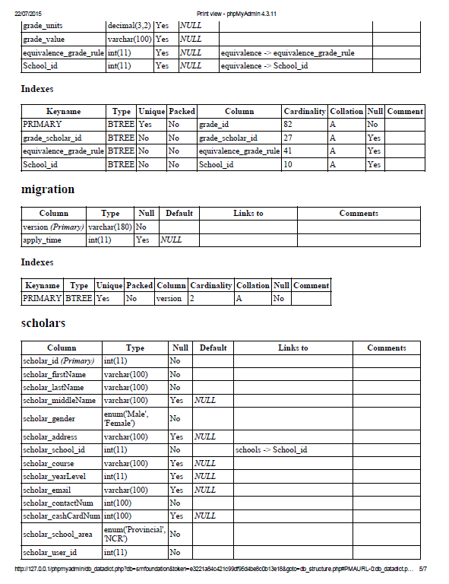

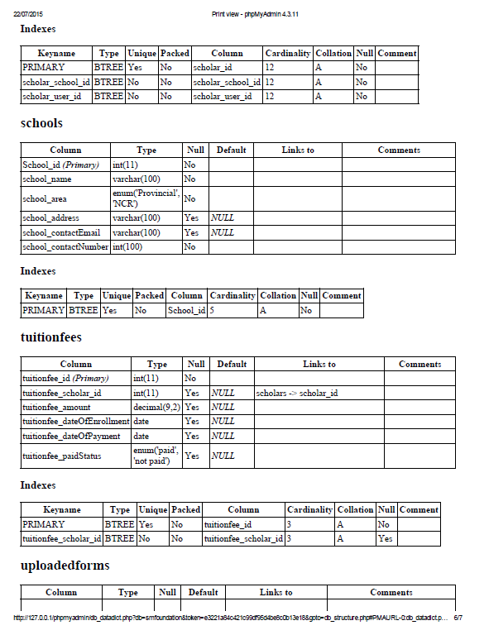

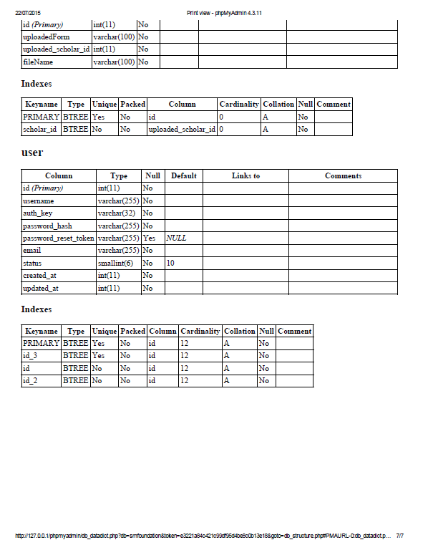

# Bibliography

Commission on Higher Education. (2015, August 12). *Higher Education Data in 2014.* Retrieved from Commission on Higher Education Official Web Site: http://www.ched.gov.ph/wp-content/uploads/2014/temp/10-03/home/Higher%20Education%20Data%202014%20-%20Public%20and%20Private%20HEIs.pdf

SM Foundation Incorporated. (2015, August 13). *About SMFI.* Retrieved from SM Foundation Incorporated Website: http://www.sm-foundation.org/aboutsmfi.html

SM Foundation Incorporated. (2015, August 13). *Education.* Retrieved from SM Foundation Incorporated Website: http://www.sm-foundation.org/education.html

World Centric. (2015, August 13). *Ecological Damage.* Retrieved from World Centric Website: http://worldcentric.org/about-compostables/traditional-paper/ecological-damage